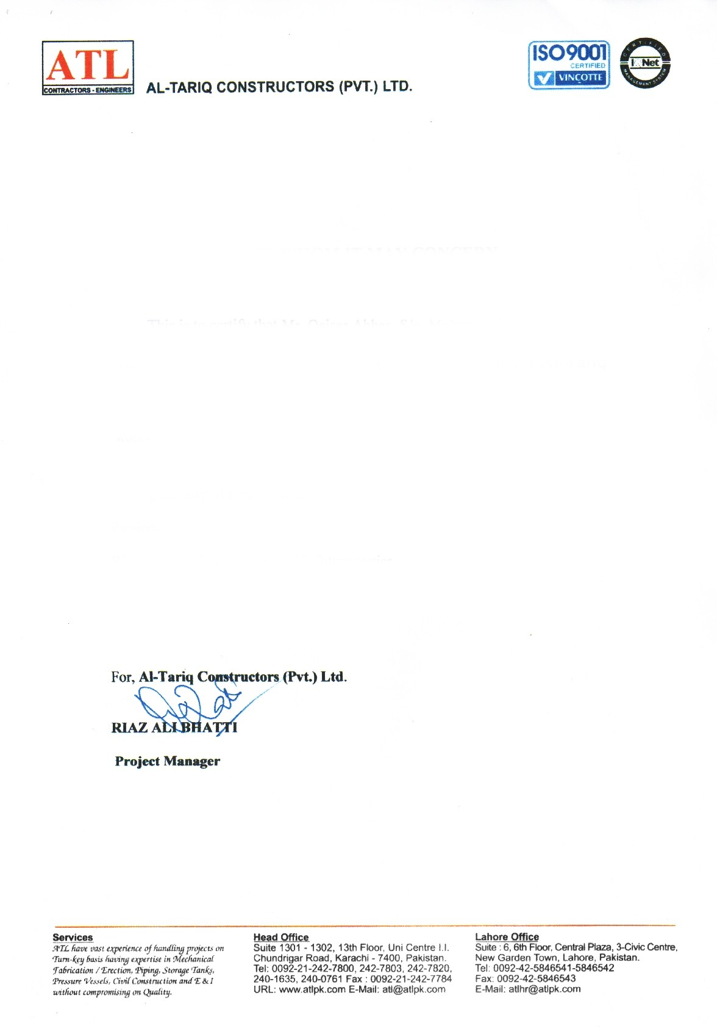

ATL/37.8/

**TO WHOM IT MAY CONCERN**

This is to certify that Mr. <Name> S/o <fname> NIC # <CNIC> has worked with our organization M/S Al-Tariq Construction (Pvt.) Ltd. As a <Designation> from <From> to <To>. Worked with project Pakistan Oil Refinery.

During his duty with us, we found him very hard working, efficient and punctual in his passion.

We wish him all the success in his future career.

